**Tema 1 de laborator**

1a)

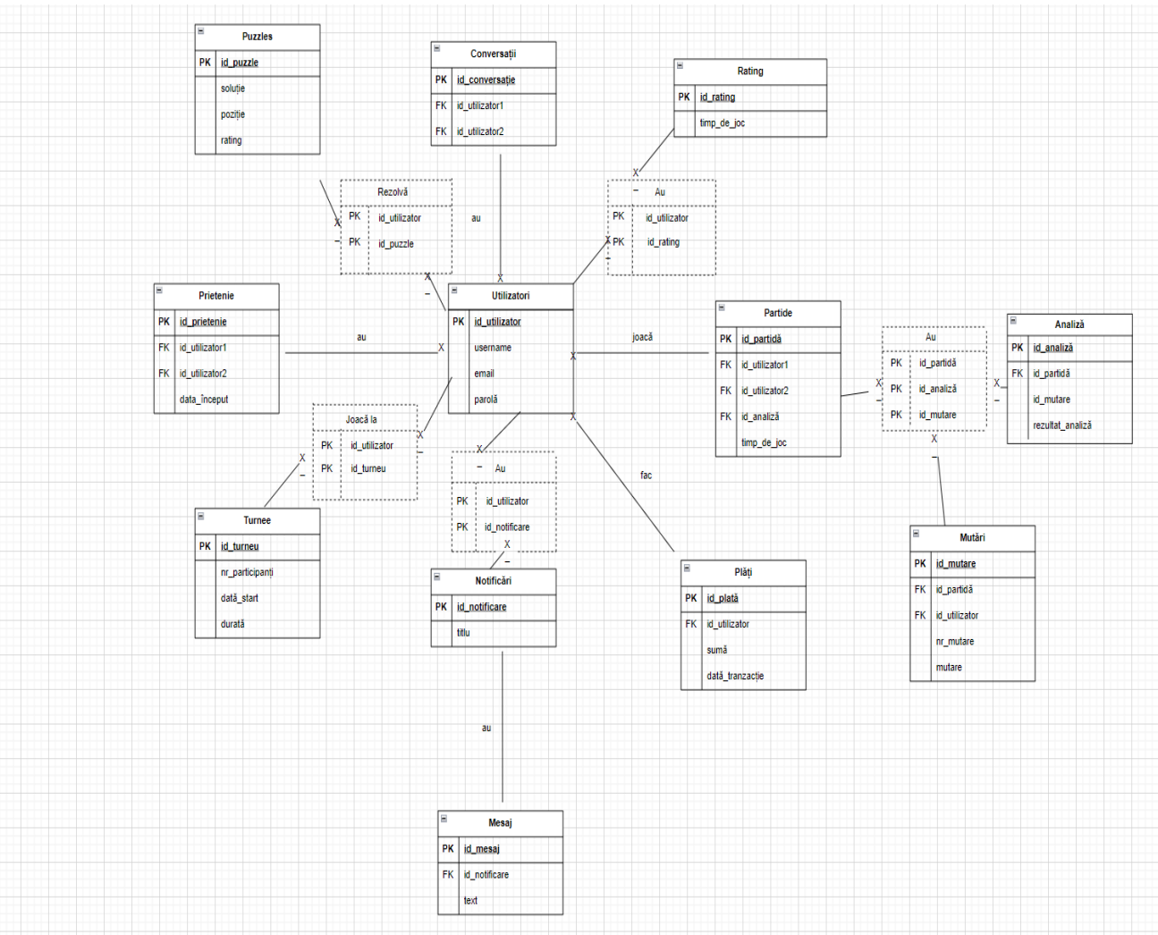

1b)

17. Generati automat un script SQL care sa contina comenzi de ștergere a tuturor tabelelor personale create:

SPOOL C:\USERS\IONUT\tema1.TXT

SELECT 'DROP TABLE ' || TABLE_NAME || ';'

FROM USER_TABLES

WHERE TABLE_NAME LIKE 'UTI%'

OR TABLE_NAME LIKE 'RATING'

OR TABLE_NAME LIKE 'PARTIDE'

OR TABLE_NAME LIKE 'ANALIZA'

OR TABLE_NAME LIKE 'MUTARI'

OR TABLE_NAME LIKE 'PARTIDEINFO'

OR TABLE_NAME LIKE 'CONVERSATII'

OR TABLE_NAME LIKE 'PUZZLES'

OR TABLE_NAME LIKE 'PRIETENIE'

OR TABLE_NAME LIKE 'TURNEE'

OR TABLE_NAME LIKE 'PLATI'

OR TABLE_NAME LIKE 'MESAJ'

OR TABLE_NAME LIKE 'NOTIFICARI';

SPOOL OFF;

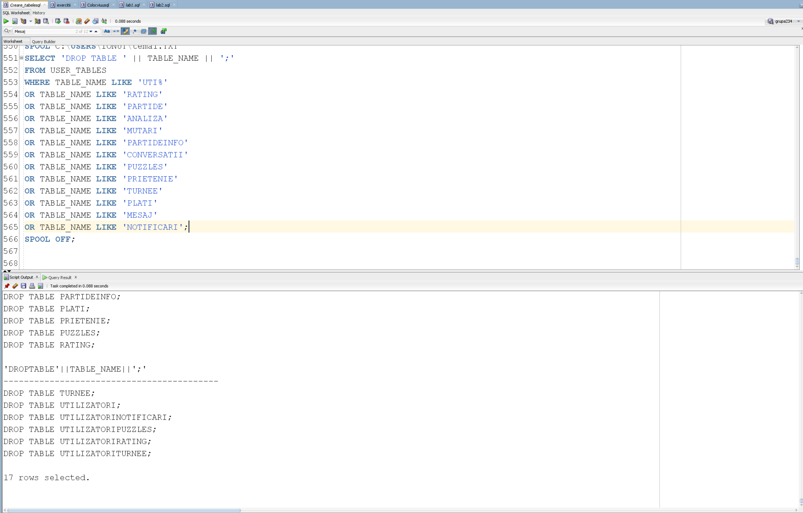

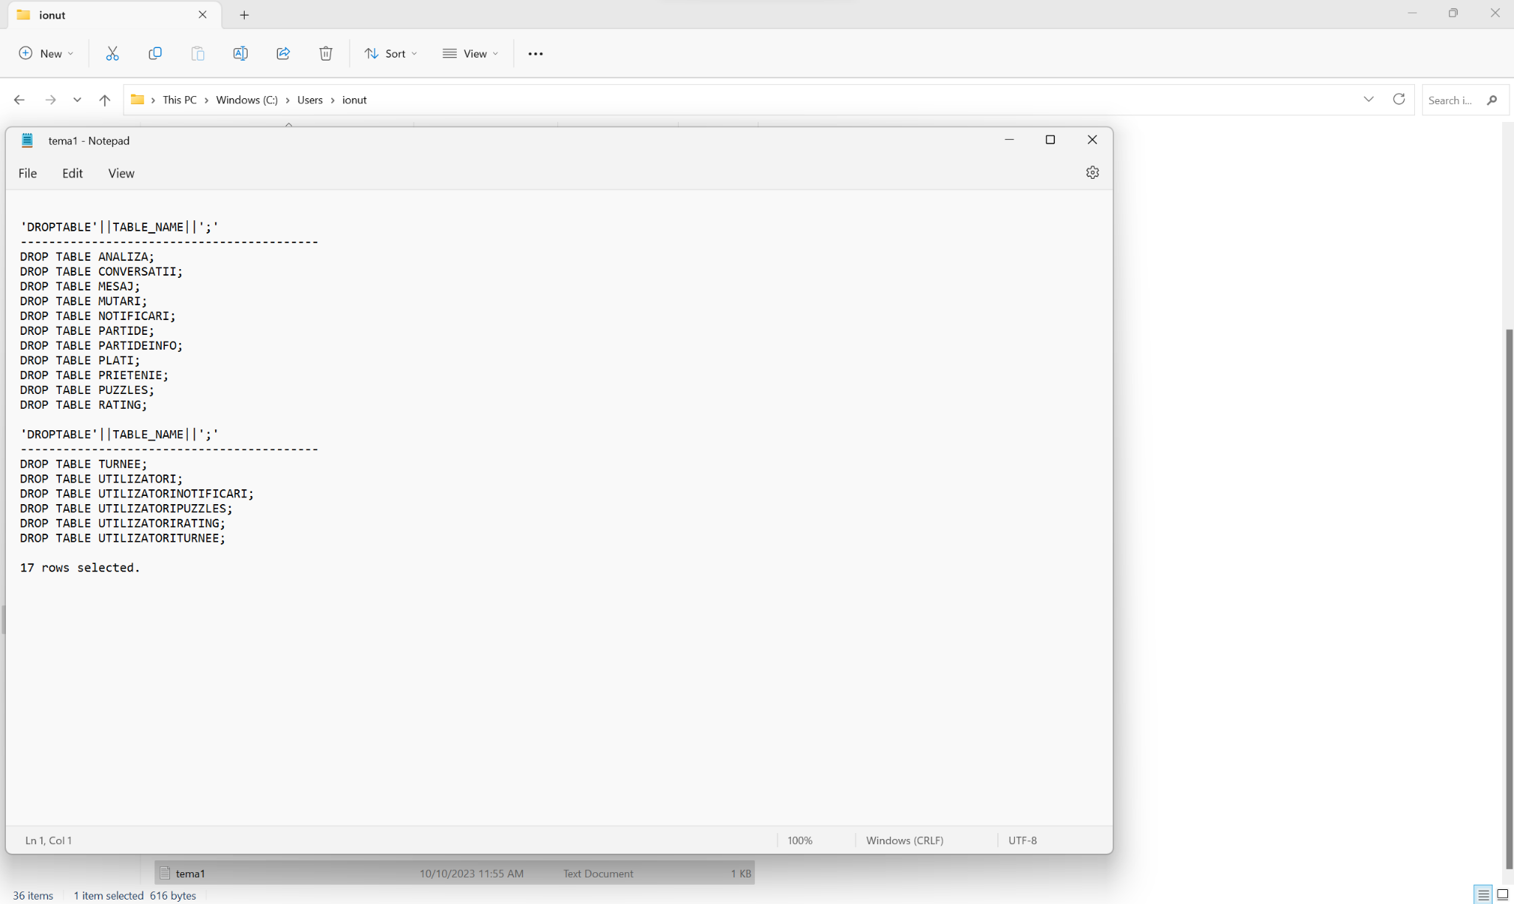

23. Folosind tabelul *Utilizatori* generati automat script-ul SQL de inserare a inregistrarilor in acest tabel:

SPOOL C:\USERS\IONUT\tema1_test.TXT

SELECT 'INSERT INTO ' || 'UTILIZATORI ' || 'VALUES ('|| ID_UTILIZATOR || ',''' || USERNAME || ''',' || EMAIL || ',' || PAROLA ||')'

FROM UTILIZATORI;

SPOOL OFF;

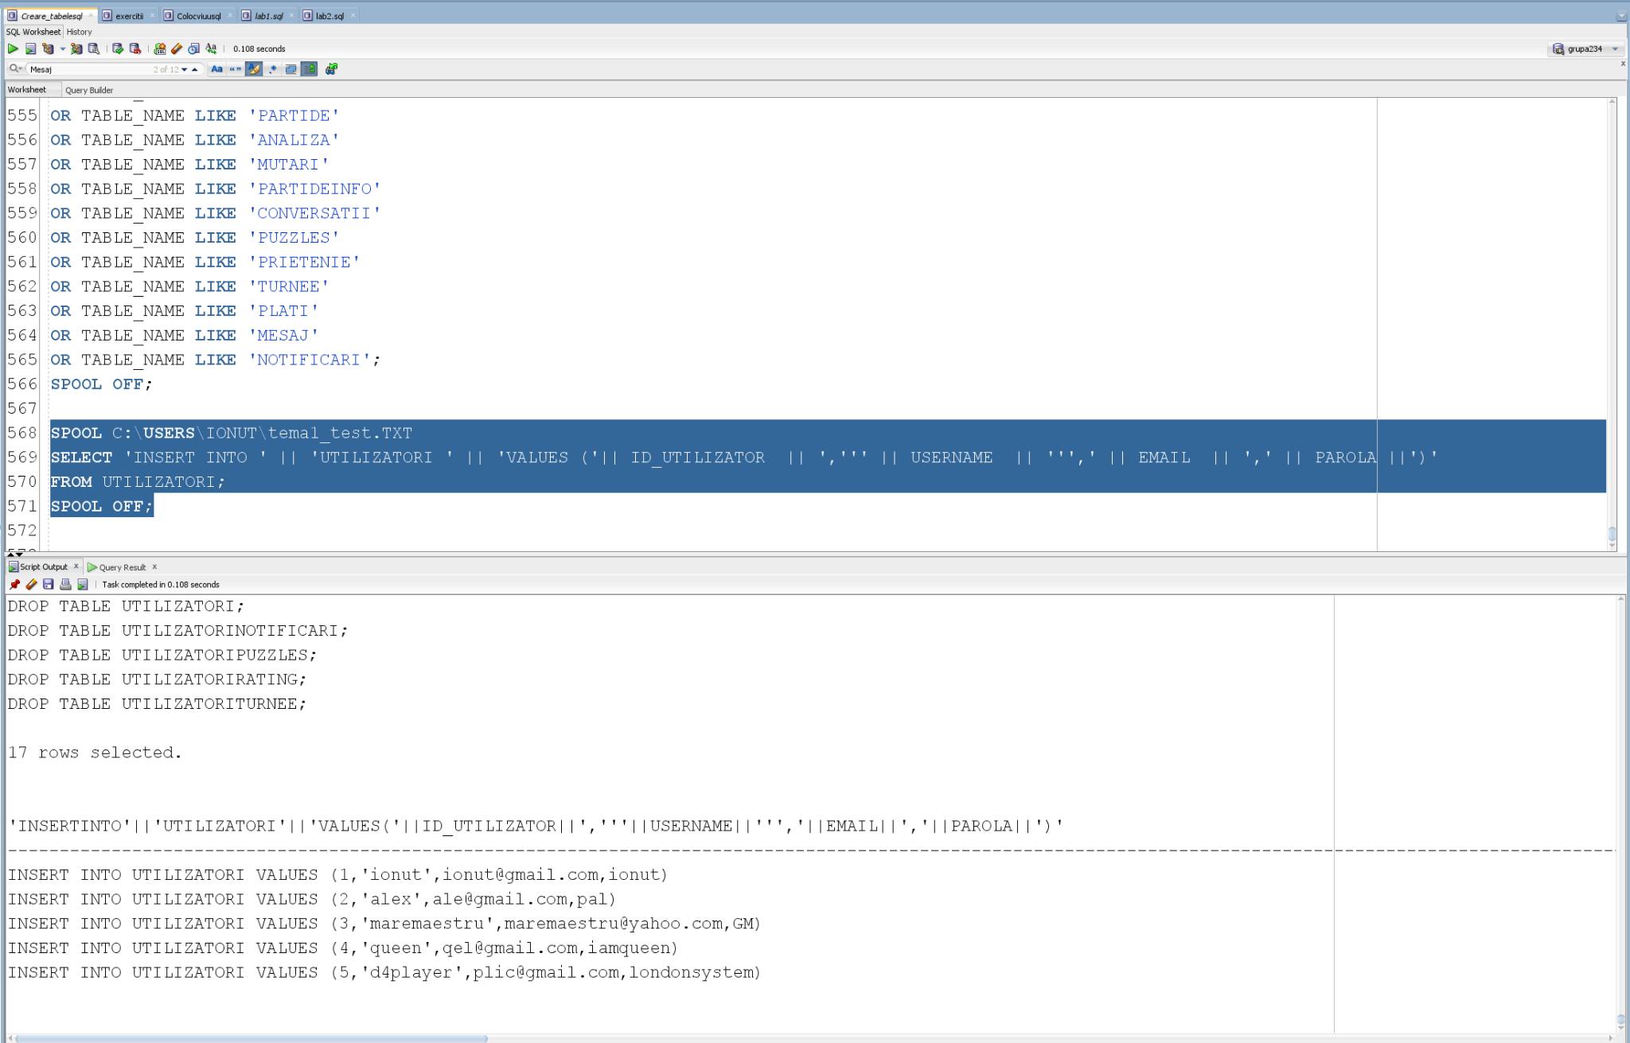

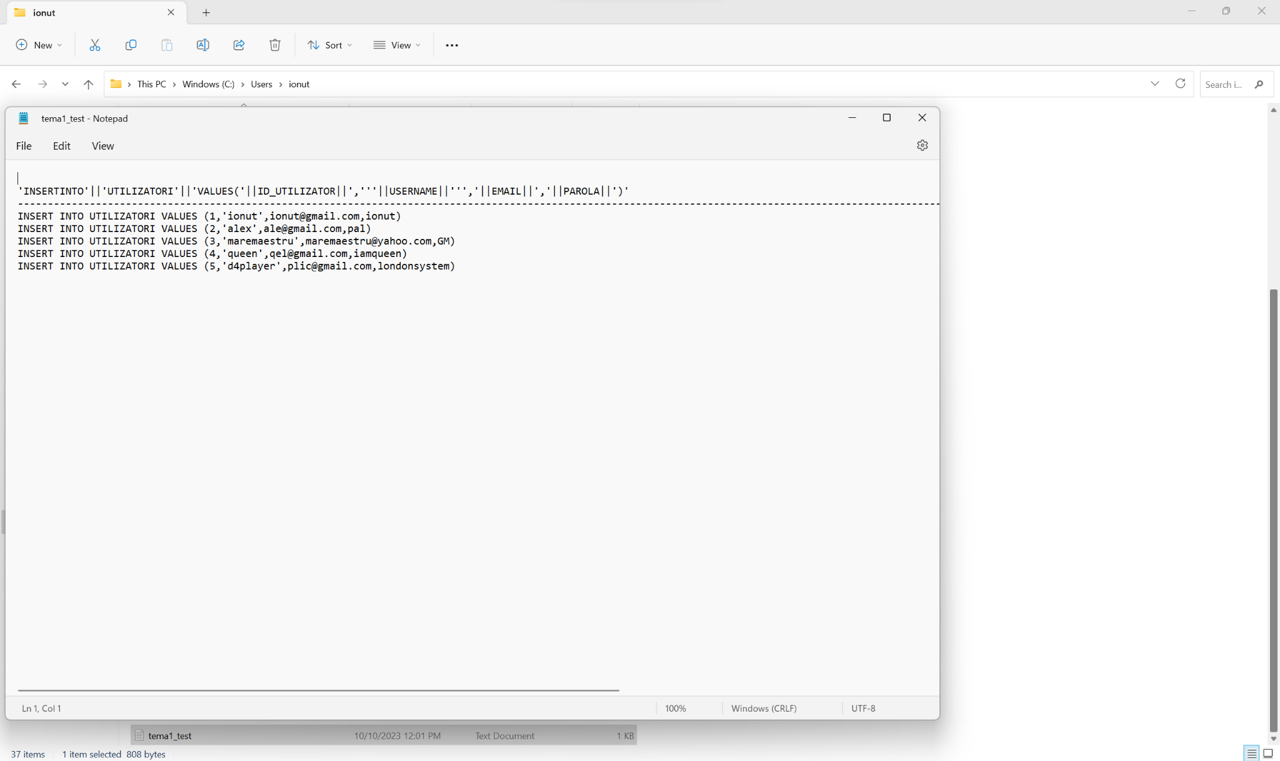

Corectare exercitiu 23 (Tratam cazul de NULL la manager_id):

SET PAGESIZE 0;

SET FEEDBACK OFF;

SPOOL C:\USERS\IONUT\lab1_test.TXT

SELECT 'INSERT INTO ' || 'DEPARTMENTS ' || 'VALUES (' || DEPARTMENT_ID || ',''' || DEPARTMENT_NAME || ''',' || NVL(TO_CHAR(MANAGER_ID), 'NULL') || ',' || LOCATION_ID ||')'

FROM DEPARTMENTS;

SPOOL OFF;

